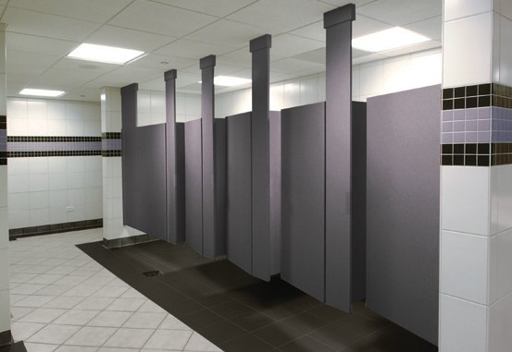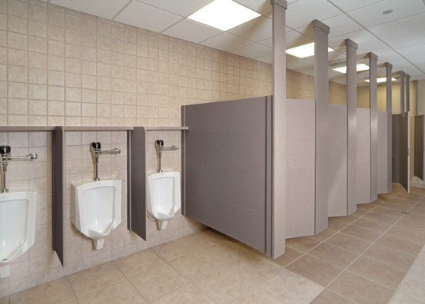

Privacy Plus Partitions
®
WITH DuPont™ Corian® solid surface
SPECIFICATIONS

SECTION 10172
PRIVACY PLUS® PARTITIONS WITH DUPONT™ CORIAN® SPECIFICATIONS
SPECIFIER:

- THROUGHOUT THIS SPECIFICATION “EDIT NOTE” IS ISSUED TO IDENTIFY ITEMS WHICH SHOULD BE CONSIDERED BY SPECIFIER DURING PREPARATION OF SPECIFICATION FOR PROJECT USE.
- QUESTIONS REGARDING THE SYSTEM, CONTACT PRIVACY PLUS® AT 847-760-0543 OR WWW.PRIVACYPLUSPARTITIONS.COM

PART 1 – GENERAL
  - RELATED DOCUMENTS

    - Drawings and general provisions of the Contract, including General and Supplementary Conditions and Division 1 Specification Sections apply to this Section.
  - SUMMARY

    - This section includes Corian® panel units as follows:

SPECIFIER: SELECT PRODUCTS APPLICABLE TO PROJECT, SELECTING CATEGORIES 1, 2, 3 AS APPROPRIATED AND TYPE OF UNIT FROM CHOICES IN BRACKETS.

      - Toilet enclosures: [overhead braced] [floor anchored] [ceiling hung] [floor and ceiling hung].
      - Entrance screens: [overhead braced] [floor anchored] [ceiling hung] [floor and ceiling hung].
      - Urinal screens: [wall hung] [floor anchored]

SPECIFIER: SELECT THE APPLICABLE RELATED SECTIONS, ADD OR DELETE REFERENCES AS APPROPRIATE TO OFFICE POLICY AND PROJECT REQUIREMENTS.

    - Related Sections include the following:
      - Division 5 Section “Metal Fabrications: for supports that attach [ceiling hung] [floor to ceiling anchored] units to overhead structural system.
      - Division 6 Section “[Rough Carpentry] [ Miscellaneous Carpentry]” for [Blocking] [and] [overhead support of floor-and-ceiling-anchored units].
      - Division 10 “Toilet and Bath Accessories” for toilet tissue dispensers, grab bars, purse shelves and similar accessories.

Privacy Plus® Partitions WITH DuPont™ Corian®solid surface
SPECIFICATIONS

SPECIFIER: INSERT PARAGRAPHS ON ALL ALLOWANCES, UNIT PRICES AND ALTERNATES IF REQUIRED FOR PROJECT.

  - REFERENCES
DuPont™ Corian® material was originally designed to have one finished side. Privacy Plus® utilizes both sides of the material, therefore the following conditions must be considered by all parties.
The “finished side” of the material will always face the outside or main areas of the room. This will ensure a uniform aesthetic. The inside of the compartments will have the “back side” exposed. Small pits caused by air bubbles, streaks in the pattern caused by aggregate pooling and color muting may be visible. These imperfections will be more prevalent in darker colors.
The exclusive Privacy Plus® sectioned panel will also aid in hiding these imperfections. A sample of the selected color will be provided for review and a signature of acceptance will be required before production will begin.
  - SUBMITTALS

    - Product Data: For each type of product indicated. Include construction details, material descriptions, dimensions of individual components and profiles and finishes.
    - Shop Drawings: Include plans, elevations, sections, details and attachments to other work.
      - Show locations of cutouts for compartment-mounted toilet accessories.
      - Show locations of reinforcements for compartment-mounted grab bars.
    - One Sample for Initial Selections: For each unit indicated.
    - Two Samples for Verification: Of each type of color, finish and back side sheet quality required for units, prepared on 4 inch- 100mm square samples of ½” thickness and material indicated for work.
    - Solid Surface Material Certification: Submit equivalency certification for tests and standards verification of material properties and characteristics for solid surface material used in product if other than Corian®.
    - Cleaning and Maintenance: Cleaning and maintenance information shall be provided by the manufacturer included with product shipment. Contractor is responsible to submit or forward the information to the Owner/Operator.
  - PROJECT CONDITIONS

    - Field Measurements: Verify all locations of walls, columns, ceilings, windows and other construction contiguous with toilet compartments by field measurements before fabrication and indicate measurements on Shop Drawings.
      - Established Dimensions: Where field measurements cannot be made without delaying the work, establish dimensions and proceed with fabricating toilet compartments without field measurements. Coordinate wall, floor, ceilings and other contiguous construction to ensure that actual dimensions correspond to established dimensions.
    - Install materials under interior environmental conditions as close to final Building conditions as possible during construction process.
    - Inspect condition of all adjacent construction to accommodate proper installation of compartments. Notify Architect and Owner of conditions which may interfere with proper installation.
  - SHIPPING AND HANDLING

    - Manufacturer will provide photograph of condition of materials, packing and shipping preparation at the time of shipping.
    - Inspect at time of receipt at job site for changes of condition, packing or damage.
    - Store materials inside, protect from weather conditions greatly different from final installation conditions.

Privacy Plus® Partitions WITH DuPont™ Corian®solid surface
SPECIFICATIONS

  - WARRANTY

    - Warranty information shall be provided by the Privacy Plus® manufacturer included with product shipment. Contractor is responsible to submit or forward information to the
Owner/Operator.
PART 2 – PRODUCTS
  - SOLID SURFACE UNITS

    - Panel Material: Homogeneous filled acrylic; not coated, laminated or of composite construction; meeting ANSI Z124.3 and 6, Type Six and Fed. Spec. WW-P-541E/Gen.
      - Material shall have minimum physical and performance properties specified in the chart as stated in Section 1.6 paragraph D.
      - Superficial damage to a depth of 0.010” (25mm) shall be repairable by sanding.
      - Material shall be ½” (13mm) thick CORIAN® solid surface.
    - Pilaster Material: Homogeneous filled acrylic; not coated, laminated or of composite construction; meeting ANSI Z124.3 and 6, Type Six and Fed. Spec. WW-P-541E/Gen.
      - Material shall have minimum physical and performance properties specified in the chart as stated in Section 1.6 paragraph D.
      - Superficial damage to a depth of 0.010”(25 mm) shall be repairable by sanding.
      - Material shall be 1” (25mm) thick CORIAN®solid surface for pilasters and vertical door edges and ½” for all other components.
    - Urinal Screen Material: Homogeneous filled acrylic; not coated, laminated or of composite construction; meeting ANSI Z124.3 & 6, Type Six and Fed. Spec. WW-P-541E/Gen.
      - Material shall have minimum physical and performance properties specified in the chart as stated in Section 1.6 paragraph D.
      - Superficial damage to a depth of 0.010”(25 mm) shall be repairable by sanding.
      - Material shall be ½” (13mm) thick CORIAN®solid surface.
    - Performance Requirements - DuPont™ Corian® solid surface standard

Tensile Strength 5000 psi min ASTM D 638
min / max)
REQUIREMENT TEST PROCEDURE
PROPERTY

Flexural Strength 7000 psi min ASTM D 790
Hardness 90 Rockwell “M” Scale min. ASTM D 785
52 Barcol Impressor min. Color Stability No Change-200 hrs. min. NEMA LD3-3.10

Wear and Cleanability PassesANSI Z 124.3
Abrasion Resistance no loss of pattern NEMA LD3.310
Wt. Loss (1,000 cycles)=0.9 gm max
Wear (10,000 cycles)=.008” max. Impact Resistance
Notched Izod .24 ft. lbs./in. of notch min. ASTM D 256 (Method A)
Gardner 9.0 ft. lbs. Min. ASTM D 3029 Drop Ball
½” (13mm) sheet >144” w ½ lb ball, no failure NEMA LD3-3.03
Stain Resistance PassesANSI Z_124.3
Fungi and Bacteria No Attack ATM G 21, G22
Flammability ¼” (6mm) ½” (13mm)
Flame Spread 25 Max 25 Max ASTM E84
Smoke Development 30 Max 30 Max
Class Rating 1 1
Pittsburgh Protocol Toxicity solid colors 80 grams min. “LG 50” Test (as used by NY State)

Privacy Plus® Partitions WITH DuPont™ Corian®solid surface
SPECIFICATIONS

SPECIFIER: SELECT NUMBER OF COLORS AND PATTERNS TO BE PROVIDED ON PROJECT. IF MULTIPLE COLORS, INDICATE COLOR LOCATIONS HERE OR REFERENCE TO DRAWINGS.

    - Color and Pattern
      - [Color and letter series] [Two colors and letter series] in each room as selected by Architect from manufacturer’s full range of colors and patterns.
    - Brackets (Fittings)
      - Continuous U-brackets [clear anodized aluminum] [stainless steel] All brackets and fittings are fully concealed by Corian® trim.

SPECIFIER: DELETE PORTFOLIO SHELF IF NO URINAL SCREENS.

    - Portfolio Shelf
      - Continuous shelf that runs perpendicular to the urinal screens and integrates to the top of each screen for temporary placement of personal items.
  - ACCESSORIES

    - Hardware and Accessories: Manufacturer’s standard design, heavy duty operating hardware and accessories, [stainless steel] [chrome plated brass].
    - Overhead Bracing (Optional): Manufacturer’s standard continuous steel clad with matching solid surface material with anti-grip profile.
    - Anchorages and fasteners: Manufacturer’s standard concealed fasteners of high strength steel. Provide pins for through-bolt applications. Recommended wall and floor anchorage to be supplied by installer.
  - FABRICATION

SPECIFIER: DELETE COMPARTMENT TYPES NOT REQUIRED FOR PROJECT.

    - Overhead-Braced Units: Provide recommended manufacturer’s standard corrosion-resistant supports, leveling mechanism, fasteners and anchors at pilasters to suit floor conditions. Make provisions for setting and securing continuous head rail of each pilaster. Provide shoes at pilasters to conceal leveling mechanism and anchorage.
    - Floor-Anchored Units: Provide recommended manufacturer’s standard corrosion-resistant anchorage assemblies complete with threaded rod, lock washers and leveling adjustment nuts at pilasters for structural connection to floor. Provide shoes at pilasters to conceal leveling mechanism and anchorage.
    - Ceiling-Hung Units: Provide recommended manufacturer’s standard corrosion-resistant anchorage complete with integrated corrosion-resistant plate bracket, lock washers and adjustment nuts at pilaster for connection to structural support above finished ceiling. Provide sleeves (caps) at pilasters to conceal anchorage.
    - Floor-and-Ceiling Anchored Units: Provide recommended manufacturer’s standard corrosion-resistant anchoring assemblies complete with leveling adjustment at tops and bottoms of pilasters. Provide shoes and sleeves (caps) at pilaster to conceal anchorage.

Privacy Plus® Partitions WITH DuPont™ Corian®solid surface
SPECIFICATIONS

E Doors: Unless otherwise indicated, provide 24 inch (610 mm) wide in-swing doors for standard toilet compartments and 36 inch (914 mm) wide out-swing doors with a minimum 32 inch (813 mm) wide clear opening for compartments indicated to be accessible to people with disabilities.
- Hinges: Manufacturer’s standard stainless steel, continuous, reversible, fully concealed with the exception of hinge knuckle, self closing to hold doors open approx. 30 degrees with emergency quick access feature.
- Latch and Keeper: Manufacturer’s standard surface mounted stainless steel latch unit designed for emergency access with a combination rubber faced door strike. Provide units that comply with requirements of authorities having jurisdiction at compartments indicated to be accessible to people with disabilities.
- Door Pull: Manufacturer’s recommended standard unit at out-swing doors that complies with accessibility requirements of authorities having jurisdiction. Provide units on both sides of doors at compartments indicated to be accessible to people with disabilities.

PART 3 – EXECUTION
  - EXAMINATION AND PREPARATION

    - Examination: Inspect conditions at installation site for acceptable conditions to assure successful final installation. Notify Architect and Owner of any unacceptable conditions. Do not proceed with any installation until unsatisfactory conditions are corrected.
    - Preparation: Perform all preparation required for satisfactory installation.
  - INSTALLATION

    - General: Comply with manufacturer’s installation instructions. Coordinate installation with installation of surrounding wall, floor and ceiling materials for a proper finished installation. Install units rigid, straight, level and plumb. Secure units in position with manufacturer’s recommended anchoring devices.
      - Maximum Clearances:
        - Door and Pilasters: ¼”
        - Panels at Walls and Pilasters: Flush
      - Panel Brackets: Align brackets at pilasters with brackets and walls.

SPECIFIER: DELETE COMPARTMENT TYPES NOT APPLICABLE TO PROJECT.

    - Overhead-Braced Units: Secure pilasters to floor and level, plumb and tighten. Secure continuous head rail to each pilaster with not less than two fasteners. Hang doors to align parallel with pilasters when doors are in closed position.
    - Floor-Anchored Units: Set pilasters with anchors penetrating not less than 2 inches (50 mm) into structural floor, unless otherwise specified. Level, plumb and tighten pilasters. Hang doors to align parallel with pilasters when doors are in closed position.
    - Ceiling-Hung Units: Secure pilasters to supporting structure above finished ceiling. Level, plumb and tighten pilaster. Hang doors to align parallel with pilasters when doors are in closed position.
    - Floor-and-Ceiling-Anchored Units: Secure pilasters to supporting construction and level, plumb and tighten pilaster. Hang doors to align parallel with pilasters when doors are in closed position.
    - Wall-Hung Urinal Screens: Secure continuous bracket to wall using manufacturer’s recommended anchorage and secure screen to bracket. Level, plumb and tighten screen.

Privacy Plus® Partitions WITH DuPont™ Corian®solid surface
SPECIFICATIONS

    - Floor-Anchored Urinal Screen: Set pilasters with anchors penetrating not less than 2 inches (50 mm) into structural floor, unless otherwise specified and secure screen to bracket. Level, plumb and tighten pilasters.

SPECIFIER: DELETE PORTFOLIO SHELF IF NOT APPLICABLE.

    - Portfolio Shelf: Connect shelf at notches at top of urinal screen. Level shelf and secure to back perimeter wall with manufacturer’s recommended wall anchorage.
  - ADJUSTING

    - Hardware Adjustment: Adjust and lubricate hardware according to Manufacturer’s recommendation for proper operation.

SPECIFIER: COORDINATE CLEANUP WITH OTHER SPECIFICATIONS FOR JOB SITE. INSERT 3.5 FOR PROTECTION OF FINISHED INSTALLATION BY CONTRACTOR.

  - CLEAN UP

    - Installer is responsible for final cleanup and wipe down of all panels, screens, pilasters and doors in accordance with the care and maintenance instructions provided by Privacy Plus®.

Privacy Plus
®

with
DuPont™ Corian®

DRAWINGS
(on the following pages)

PILASTER
(VARIES IN WIDTH)

3 CORIAN®FLOOR BOOT COVER

FLOOR LINE

ANCHOR BOLT
(BY OTHERS)

INTEGRATED STEEL FLOOR MOUNT
PRIVACY PLUS
www.privacypluspartions.com
FLOOR MOUNT FRONT ELEVATION
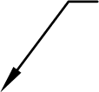

2" CAP
CORIAN CROWN
1.0“

ALUMINUM U CHANNEL

0.125'
0.75" 0.25 ' DIA PIN

1.0"
PRIVACY PLUS
www.privacypluspartions.com
1 PILASTERS WITH CORIAN CAP SECTION ELEVATION
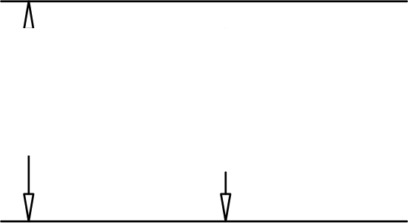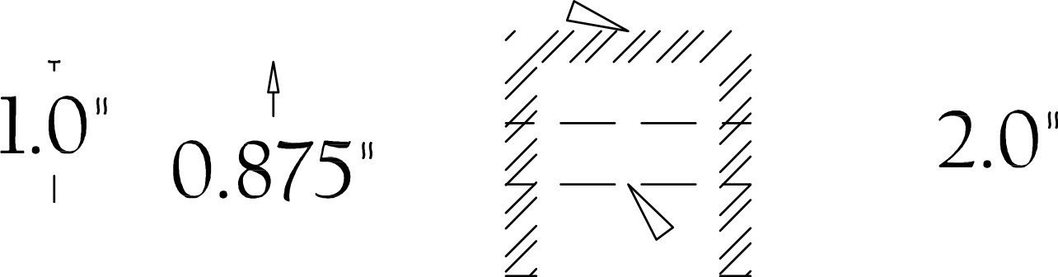

Privacy Plus® Partitions WITH DuPont™ Corian®solid surface

SPECIFICATIONS

Privacy Plus® Partitions WITH DuPont™ Corian®solid surface

SPECIFICATIONS

Privacy Plus® Partitions WITH DuPont™ Corian®solid surface

SPECIFICATIONS

600 | 18" | 104 '  604'  MINIMUM 34" ADA  36" | “ | 3„  38-"  AMBULATORY STALL  32" CLEARANCE WHEN DOOR IS AT 90  32'
PRIVACY PLUS
www.privacypluspartions.com
2 STALL PLAN WITH AMBULATORY STALL IN MIDDLE OF RUN
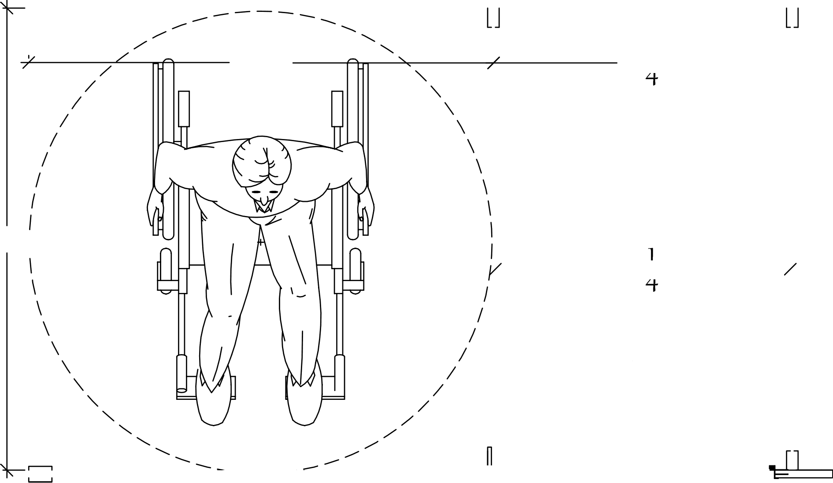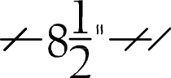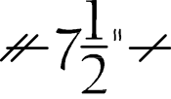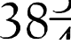

THE NUMBER OF GRAB BAR BLOCKS WILL BE DETERMINED
\ BY SPECIFIED GRAB BAR

AMBULATORY STALL

‘= —— , 32" CLEARANCE MINIMUM 34" ADA !
DOOR FOR 32 CLEAR WHEN DOOR IS AT 90
18 32"
PRIVACY PLUS‘
www.privacypluspartions.com
2 STALL PLAN WITH AMBULATORY STALL AT BUILDING WALL
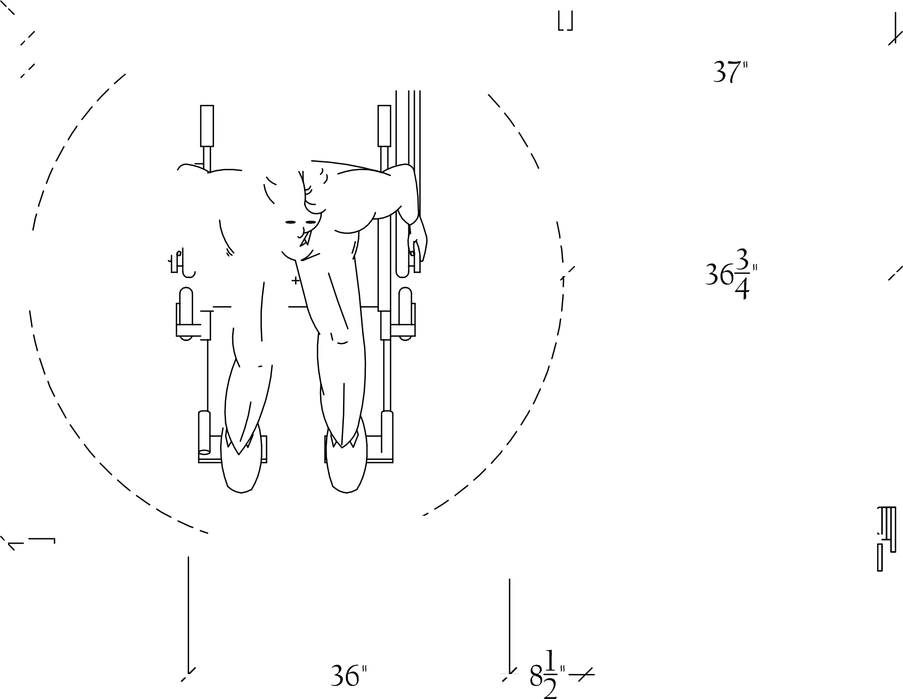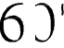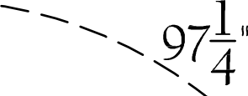

INTEGRATED GALVANIZED PLATE STEEL
1/4 ' BOLTS AND NUTS
FACE OF STEEL C CHANNEL

6" MIN BOTTOM
OF STEEL
( AS C LOS F. TO FI $ H F D C F1 L I N th AS Pr9SS IP L F

FINISHED
3" CORIAN®CEILING CEILING LINE
COLLAR COVER

CONTRACTOR
PILASTER
WIDTH VARIES SUPPLIED DIMENSION

FINISHED FLOOR

”'C" CHANNEL SIZED TO STIFFLY SUPPORT OF 300 to 350 LBS. PER STALL OPENING CROSS STIFFENERS MAY BE REQUIRED
PRIVACY PLUS
www.privacypluspartions.com
CEILING MOUNT FRONT ELEVATION
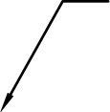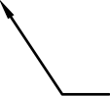

BACK WALL
INTEGRATED GALVANIZED STEEL

60 FACE OF TYPICAL STEEL "C
BEAM

STEEL 'C" BEAM (MINIMAL 6" WIDE) (BY OTHERS)
BOTTOM OF STEEL
( \S CLCiSL TO FINISHED CEILING AS Pt9SSIBLE)

FINISHED CEILING 3 CORIAN®CEILING LINE
" COLLAR COVER

1" PILASTER

®
60" TYP.
PRIVACY PLUS‘
www.privacypluspartions.com
CEILING MOUNT SIDE ELEVATION
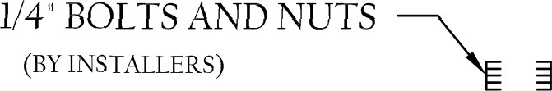

1' PILASTER

3 ' CORIAN®FLOOR
INTEGRATED BOOT COVER
STEEL FLOOR
PLATE MOUNT FLOOR LINE
ANCHOR BOLT
(BY OTHERS)
PRIVACY PLUS
www.privacyp1uspartions.com
FLOOR MOUNT SECTION ELEVATION
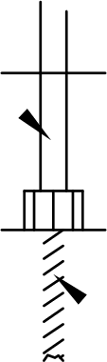

SELF CLOSING STAINLESS STEEL HINGE STAINLESS STEEL HINGE
(IN SWING HINGE REST AT 10‘ 15‘ AJAR)

®
CORIAN PILASTER
CORIAN® DOOR

STEEL PIN
PRIVACY PLUS
www.privacypluspartions.com
HINGE APPLICATION SECTION DETAIL
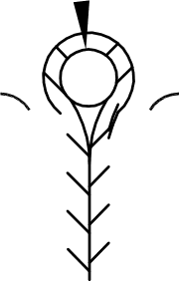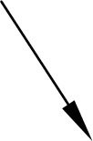

Privacy Plus® Partitions WITH DuPont™ Corian®solid surface

SPECIFICATIONS

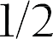Privacy Plus® Partitions WITH DuPont™ Corian®solid surface

SPECIFICATIONS

®

®

 | CONFIRM FINISHED WALL TO FRONT OF BEAM
 | STEEL STRUCTURAL SUPPORT
 | (B\’ tOTH ERS)
 | FINISHED CEILING
 |  |  | OPTIONAL
 |  |  | 3" CORIAN®
 | 1' THICK PILASTER |  | COLLAR
BACK WALL |  | <
 | 61
EQUAL
EQUAL | ®
 |  |  | 60
EQUAL
EQUAL
 | FLOOR
PRIVACY PLUS
www.privacyp1uspartions.com
SIDE PANEL ELE\‘ATION CEILING MOUNT
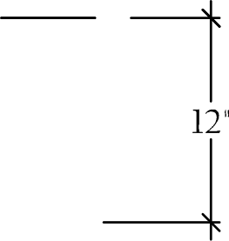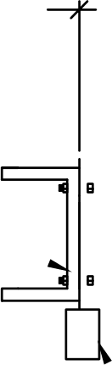
CONFIRM HEIGHT OF FINSIHED FLOOR TO BEAM

 | CONFIRM FINISHED WALL TO FRONT OF BEAM
 | STEEL STRUCTURAL SUPPORT
 | (B\' OTHERS)
 | FINISHED CEILING
 |  | OPTIONAL
 |  | 3 ' CORIAN®
 | 1" THICK PILASTER | COLLAR
BACK WALL
EQUAL
EQUAL | ®
EQUAL
EQUAL
 | ®
 | 3" CORIAN ROOT
 | FLOOR
PRIVACY PLUS‘
www.privacypluspartions.com
SIDE PANEL ELEVATION CEILING & FLOOR MOUNT
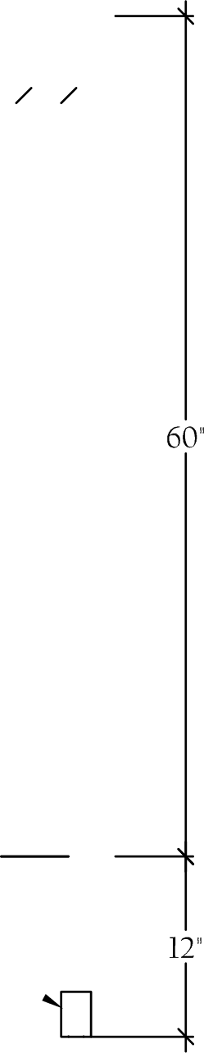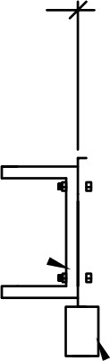
CONFIRM HEIGHT OF FINSIHED FLOOR TO BEAM

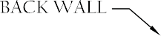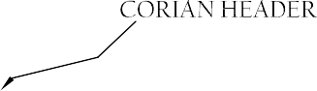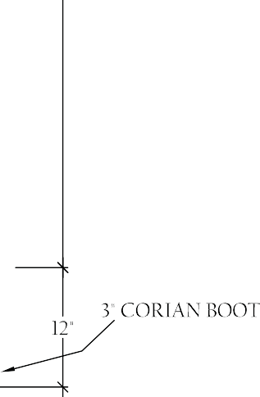Privacy Plus® Partitions WITH DuPont™ Corian®solid surface

SPECIFICATIONS

®

®

®

Privacy Plus® Partitions WITH DuPont™ Corian®solid surface

SPECIFICATIONS

Privacy Plus® Partitions WITH DuPont™ Corian®solid surface

SPECIFICATIONS

®
CORIAN I' PILASTER

THREADED MECHANICAL INSERT

CONTINUOUS
» ALUMINUM "U' CHANNEL

STEEL PIN

®
CORIAN COVER STRIPS

®
CORIAN PANEL
PRIVACY PLUS‘
www.privacypluspartions.com
PLAN DETAIL ALUMINUM U ' CHANNEL & COVER STRIP FOR PARTITION ANCHOR TO PILASTER

WALL ANCHOR
(BY OTHERS)

CONTINUOUS
r ALUMINUM U' CHANNEL

STEEL PIN

CORIAN®COVER STRIPS

CORIAN® PANEL
PRIVACY PLUS
www.privacyp1uspartions.com
PLAN DETAIL FOR ALUMINUk4 U' CHANNEL & COVER STRIP FOR PRIVACY PLUS & URINAL SCREENS

Privacy Plus® Partitions WITH DuPont™ Corian®solid surface

SPECIFICATIONS

PORTFOLIO SHELF OR STABILIZER CAP

STABILIZER CAP OR PORTFOLIO SHELF

STIL L kNER GLUED
gWALL IN THE FIELD
3" x j' TRIM

SIDE VIEW
PRIVACY PLUS‘
www.privacypluspartions.com
STANDARD URINAL SCREEN TOP AND SIDE VIEW
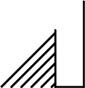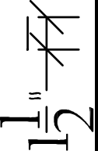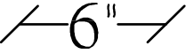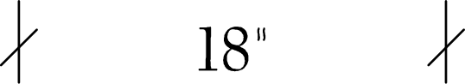
58"

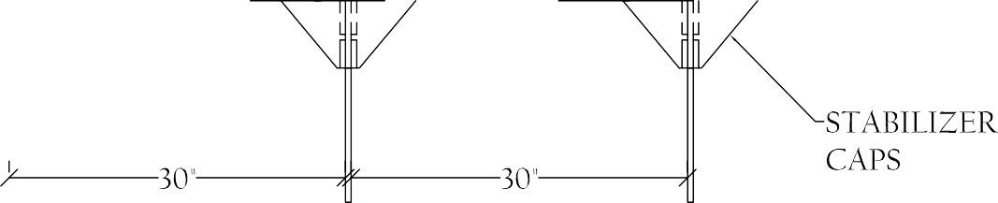Privacy Plus® Partitions WITH DuPont™ Corian®solid surface

SPECIFICATIONS

Privacy Plus
®
Partitions
WITH DuPont™ Corian®solid surface

SPECIFICATIONS

Privacy Plus
®
with

For more information about Privacy Plus® Partitions with DuPont™ Corian®,please call 847-760-0543 or visit PrivacyPlusPartitions.com.
DuPont™
Corian®

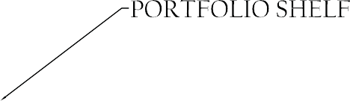

The DuPont Oval logo, DuPont™ and Corian® are trademarks or registered trademarks of E.I. du Pont de Nemours and Company and are used under license by Gerali Custom Design, Inc. GREENGUARD Indoor Air Quality Certified® is a registered trademark of GREENGUARD Environmental Institute. NSF and the mark are registered trademarks of NSF International. Privacy Plus® is a registered trademark of Gerali Custom Designs, Inc. All rights reserved.
K27481 (4/14)

